# Generating Files – by Alex Foden

This is a general overview on how to generate a CIF, a phase file, a bin file and how to implement these in the RTM code. Current the code reads from a HDF5 file type for data and has a conversion tool for Bruker files (BCF) to HDF5. It outputs an HDF5 file and plots it in MTEX.

For an overview on the refined template method, please see <https://arxiv.org/abs/1807.11313>

For versions and requirements see the read me file in GIT

## CIFs

CIFs (crystallographic information files), for many phases can be found online via a google search or in the Crystallography open database (COD): <http://www.crystallography.net/cod/>

If you require a specific CIF file, that is unavailable on the COD, software can be found to generate a CIF file such as *Vesta*: <http://jp-minerals.org/vesta/en/>

These are needed in the RTM indexing to provide symmetry information when generating the library

### Using *Vesta*

Open *Vesta*

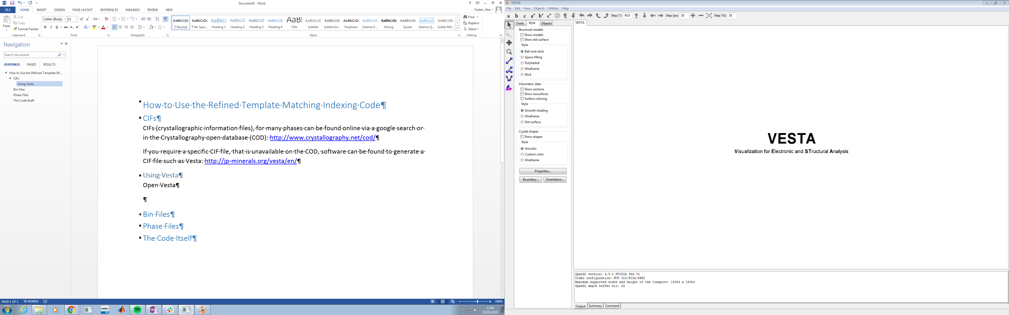

In the top left hand corner, click *File* and select *New Structure*. Alternatively, windows users can press *ctrl + n* on the keyboard

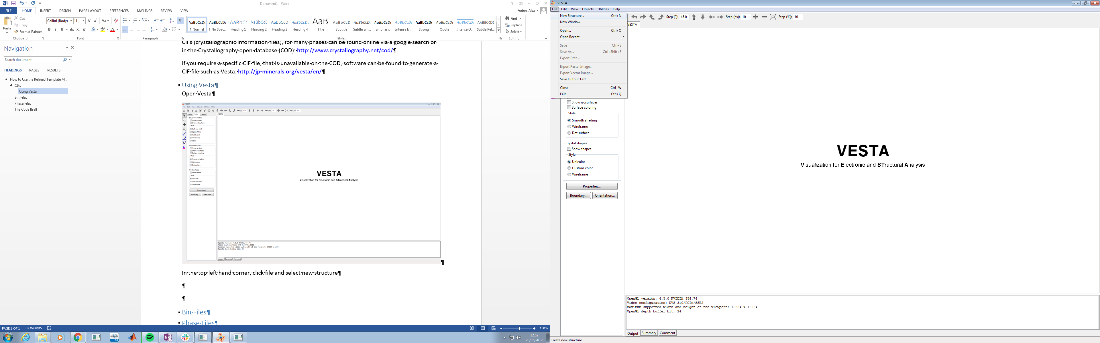

This will open the following window

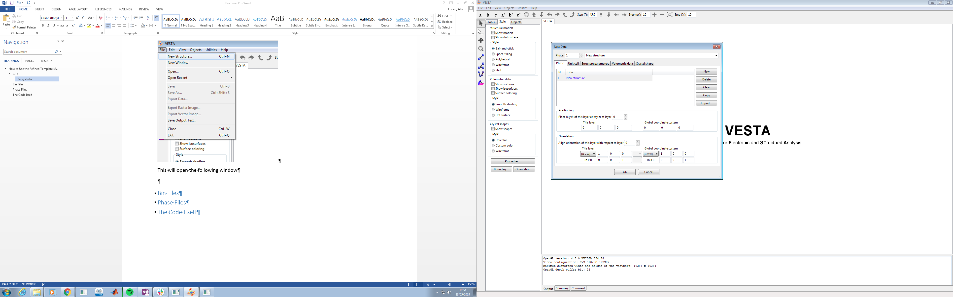

Here you can use the tabs to input the crystallographic information you need. The basics are as follows:

Select *Unit Cell* to choose the symmetry of the unit cell, and unit cell properties

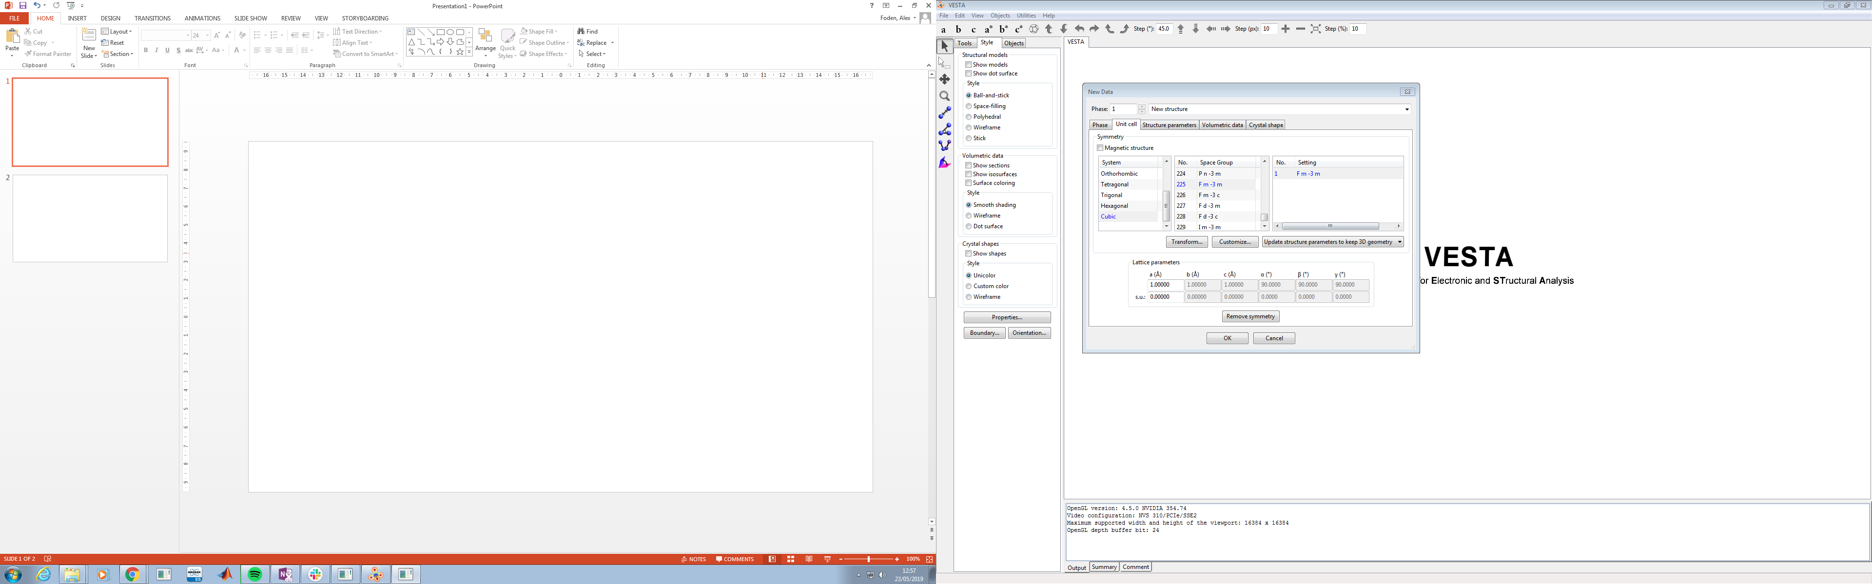

Once you have input your unit cell, select *Structure Parameters* to add atoms

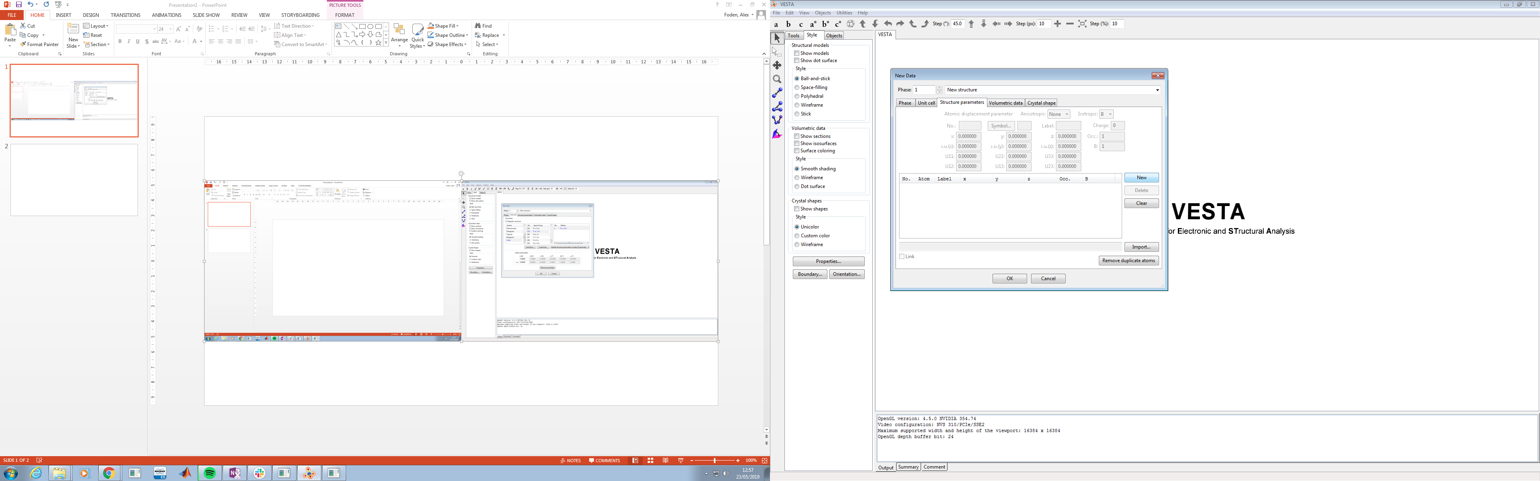

Click *New*, then select *Symbol*

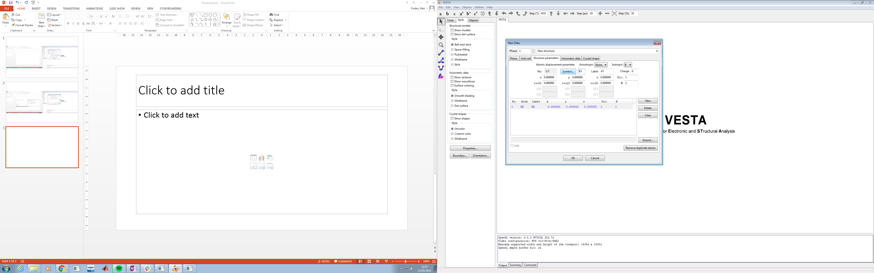

Once you have selected *Symbol*, a periodic table will open in a new window, use this to select the atom you want

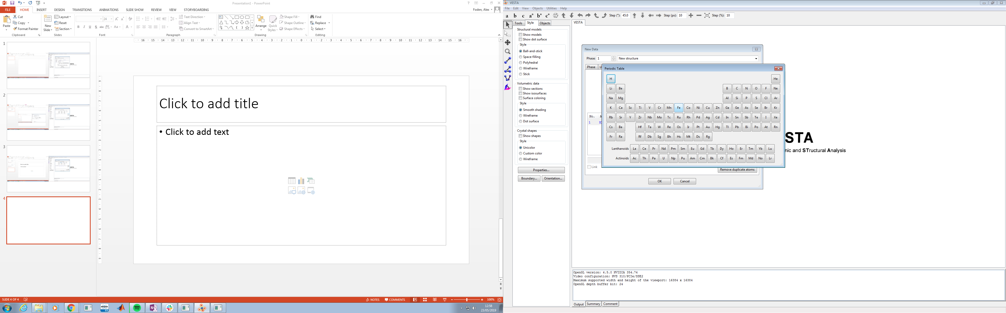

Fill in the remaining properties and any specifics you need, then click *ok*, this will then show you your unit cell

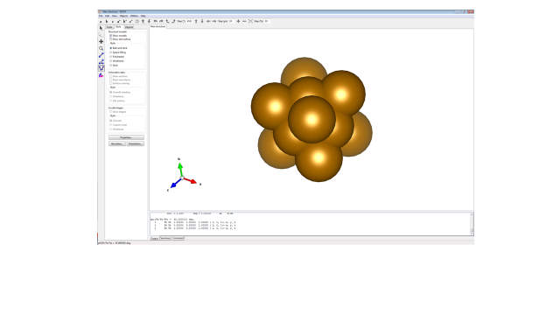

To save as a CIF, select *File* in the top left hand corner and select *Export Data*

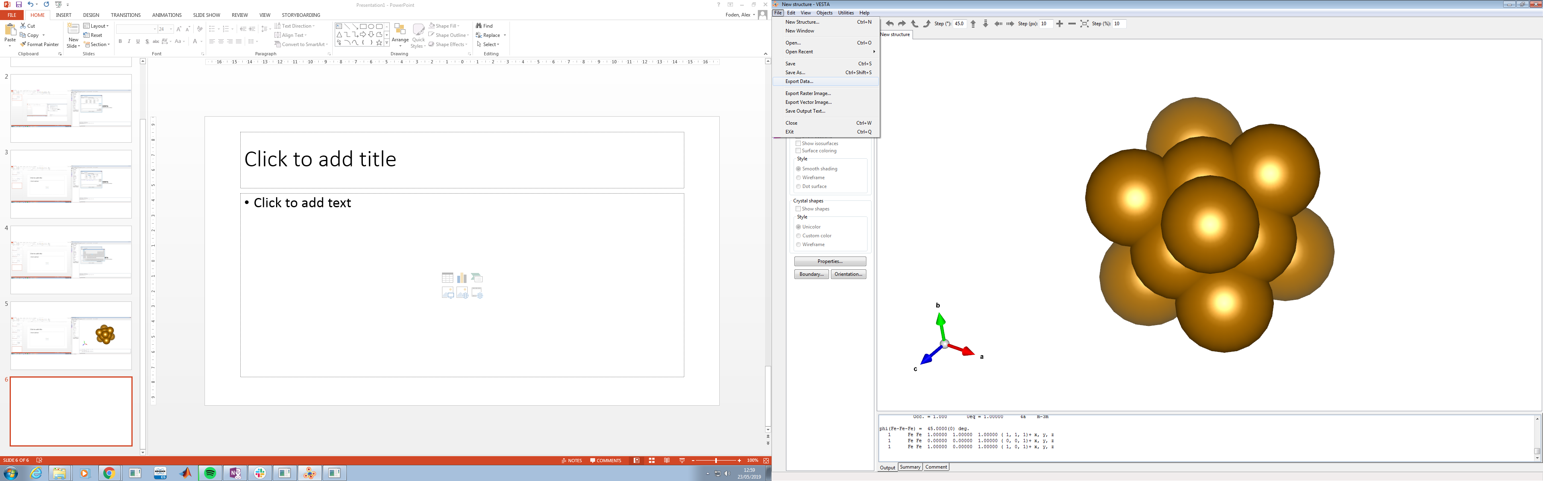

This will open a new window. Name the file and then select *CIF* from the drop down menu. Click *Save*.

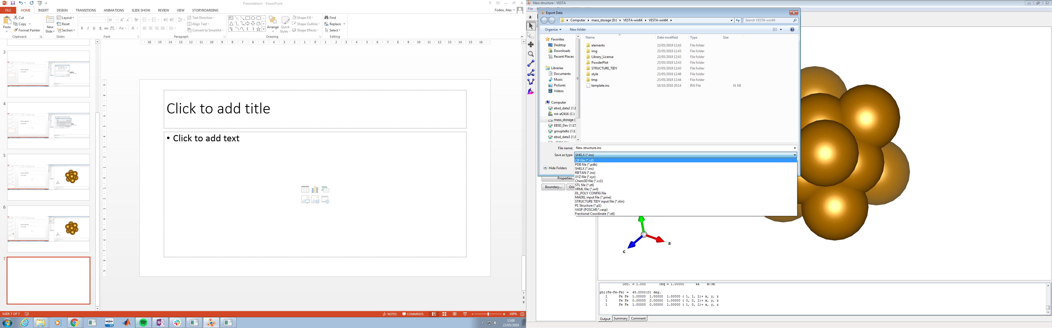

## Bin Files

In order to generate the images in the library, we need to gather the simulated diffraction information. This is stored in a BIN file in the form of a cube of diffraction information.

To generate a BIN file, you will need two pieces of software, *Bruker Esprit* and *Bruker DynamicS*.

*Esprit* can take in a CIF and use this to generate a .phl file, readable by *DynamicS*. Or can be used to generate a unit cell.

*DynamicS* then takes the .phl file and dynamically simulates a diffraction pattern

### Using *Esprit*

Open Esprit

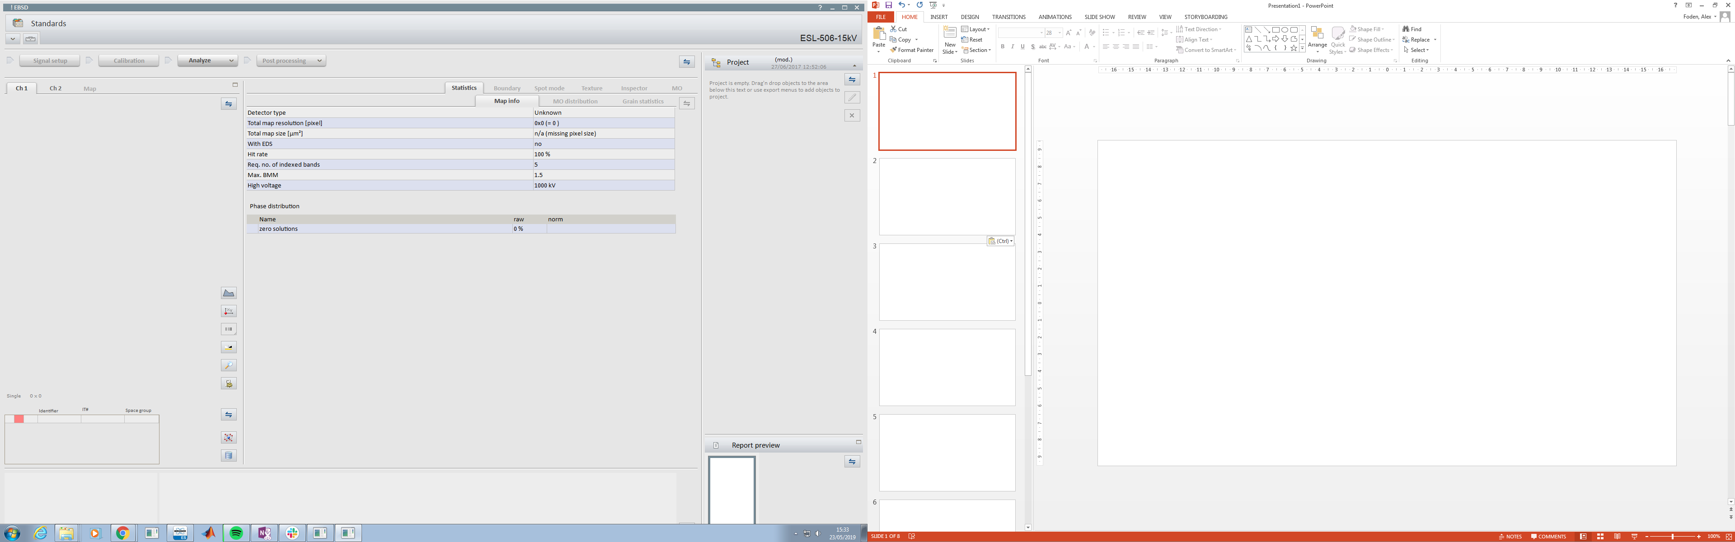

#### To work with a CIF

In the bottom left corner, click the unit cell button.



This will open a new window

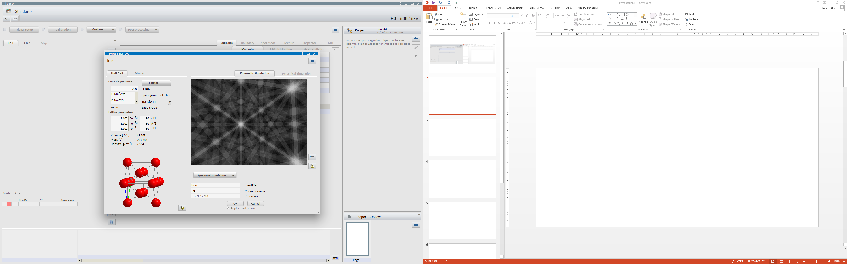

In the top right, click the two arrows and then select *New*

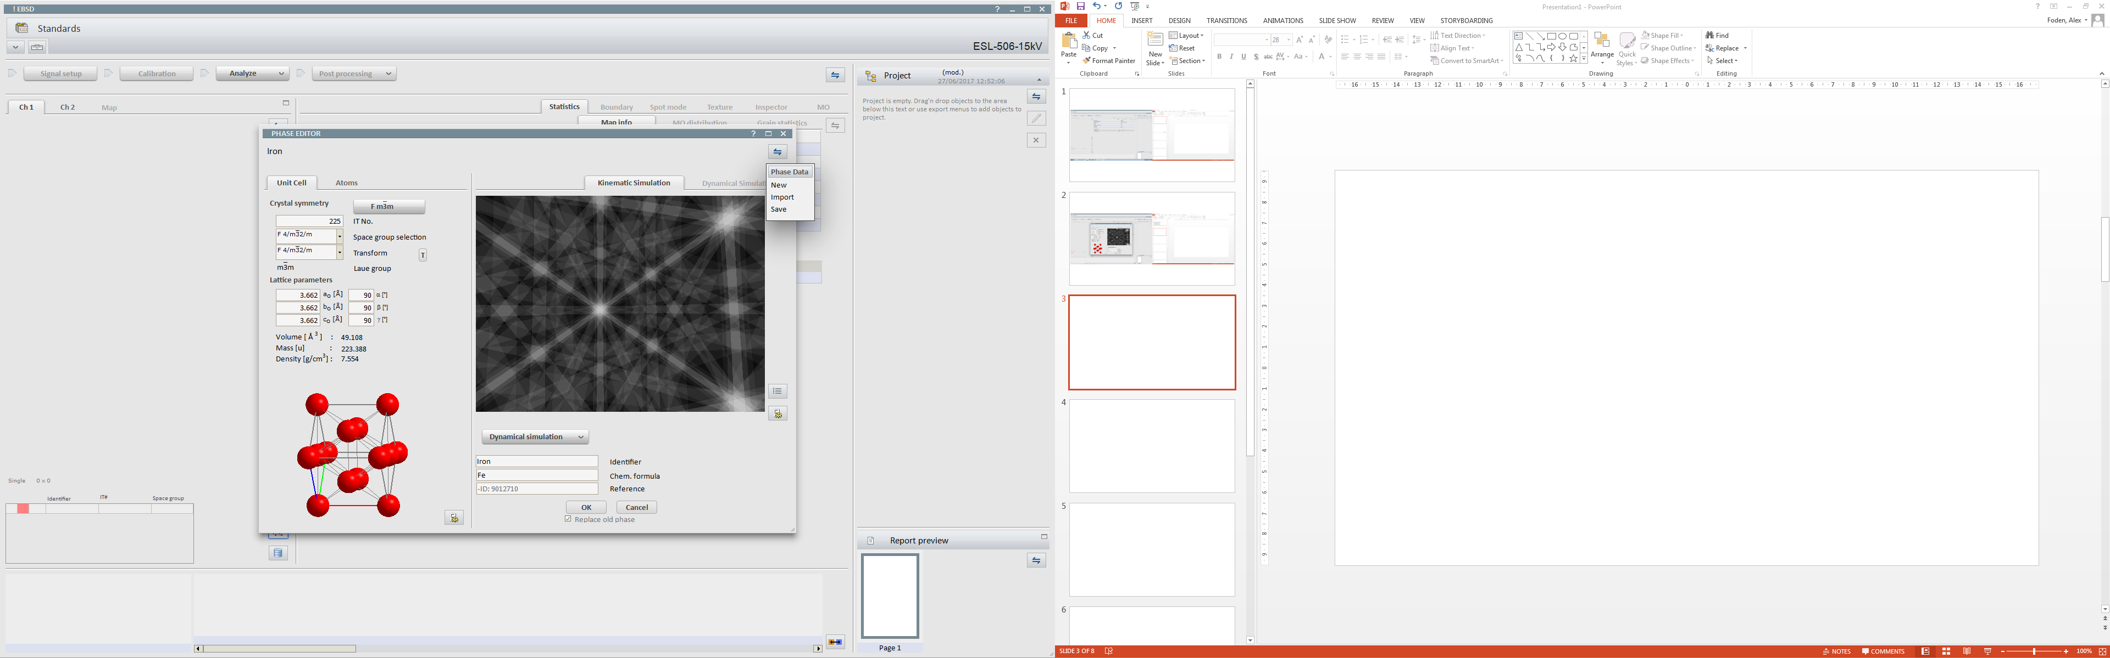

Click the arrows again and then and select *Import*



Select the CIF you wish to use, in this case the CIFs shown are in MTEX

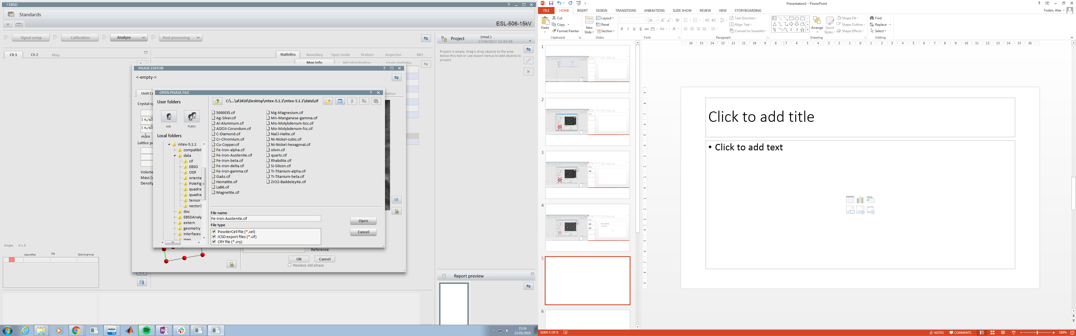

This will load the unit cell

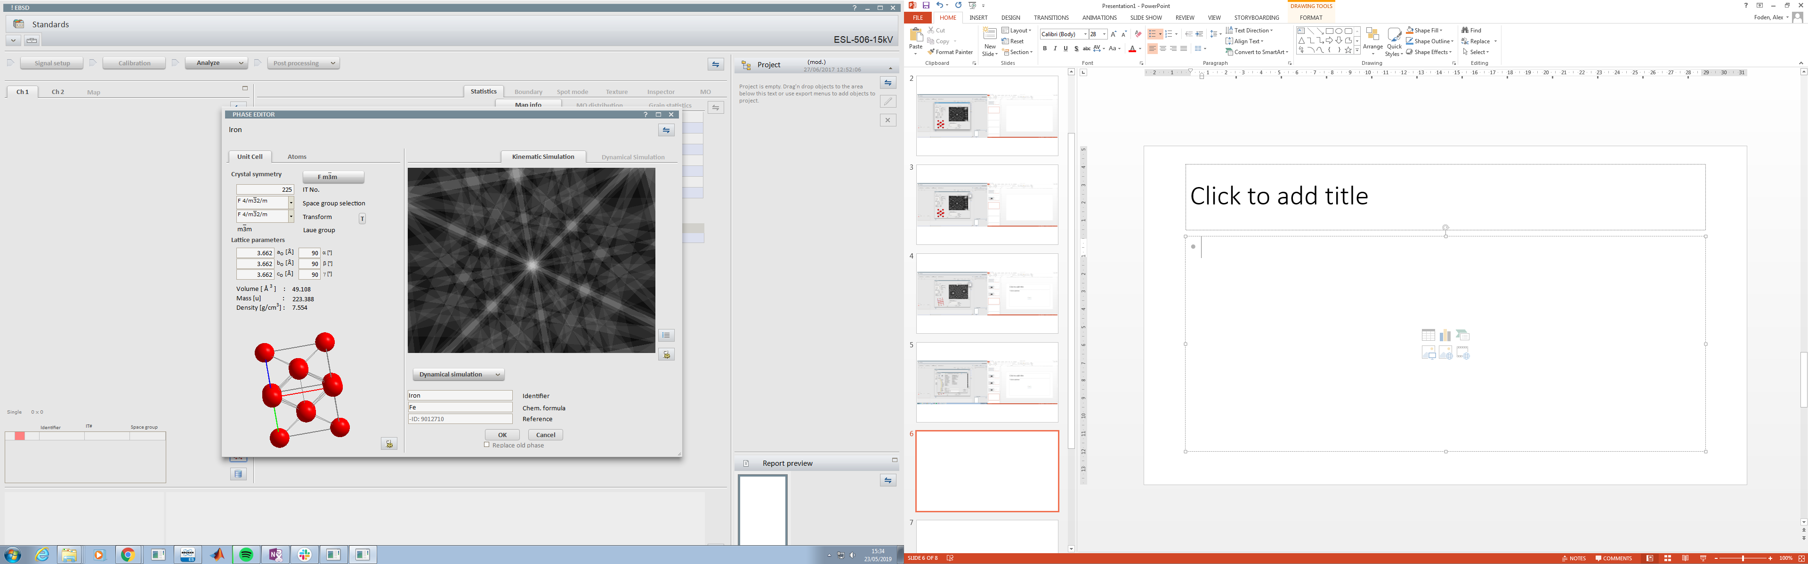

Click *OK.* This will add the phase to your phase list

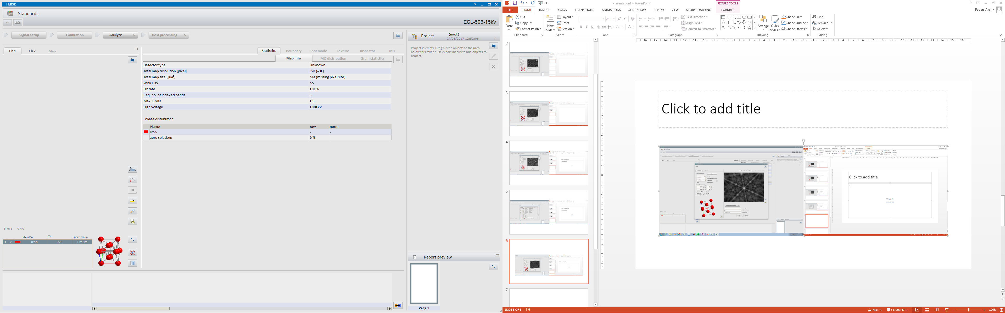

#### To work with Esprit

In the bottom left hand corner, click the stack button

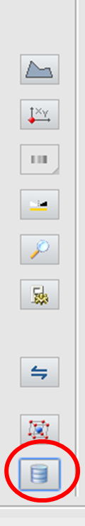

This will open a new window. In the search bar type the element symbol you wish to use, and select the crystal structure for that element. Then click *Add*, this will add it to the phase list.

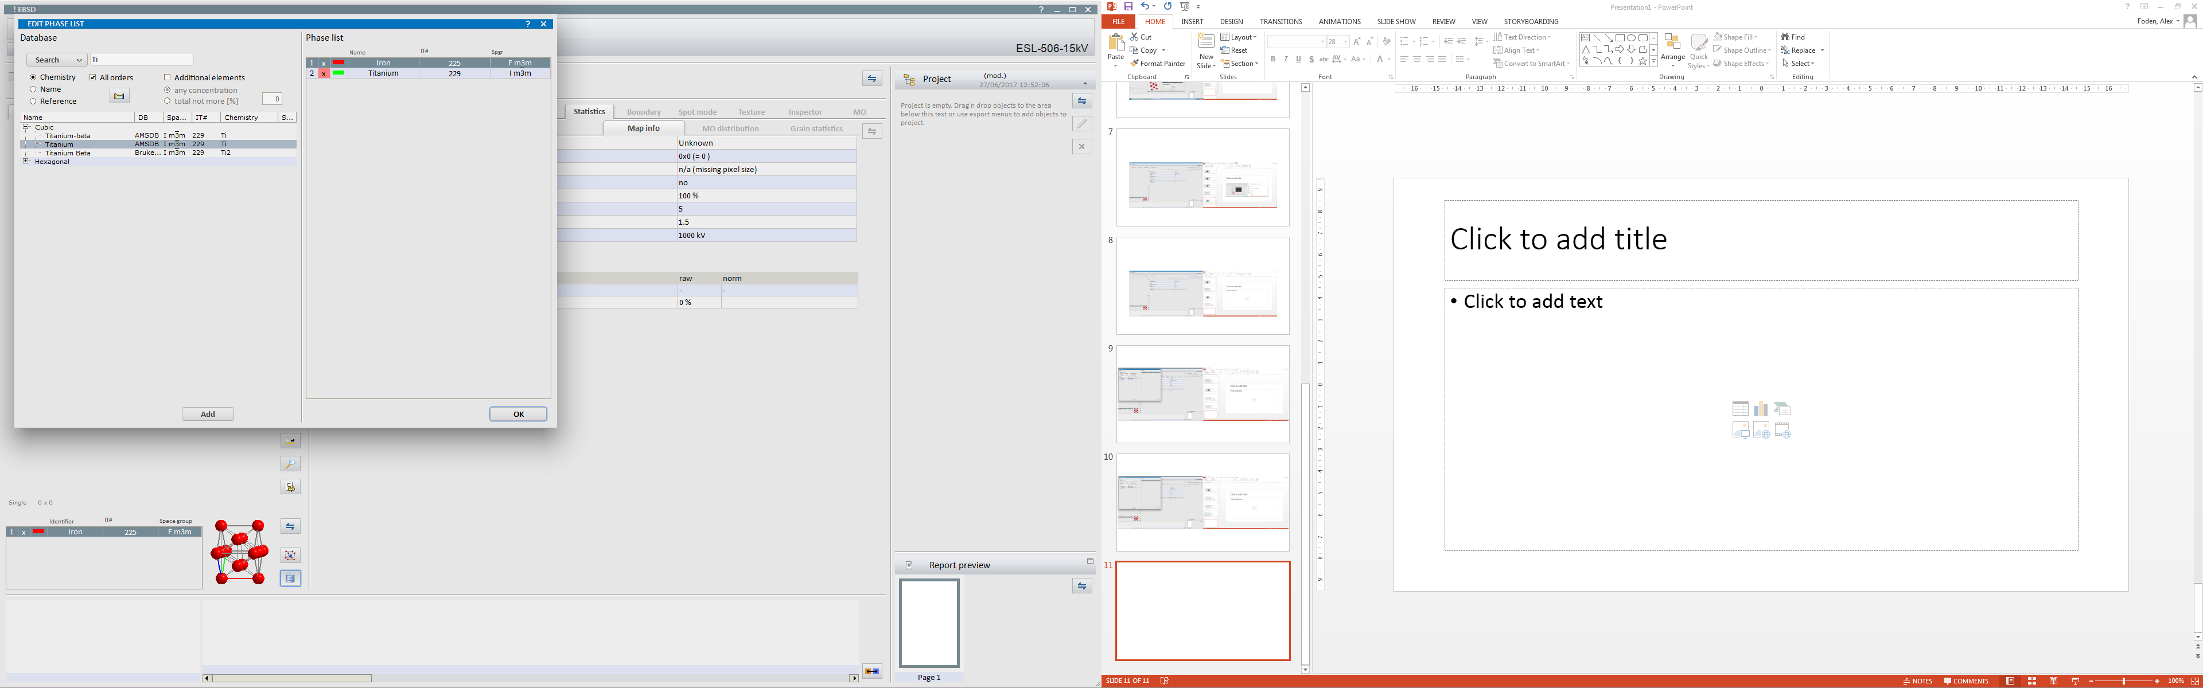

Clicking *OK* will return you to the main *Esprit* window.

#### Saving the Phase list as a .phl

In the lower left hand corner, click the two arrows and select save

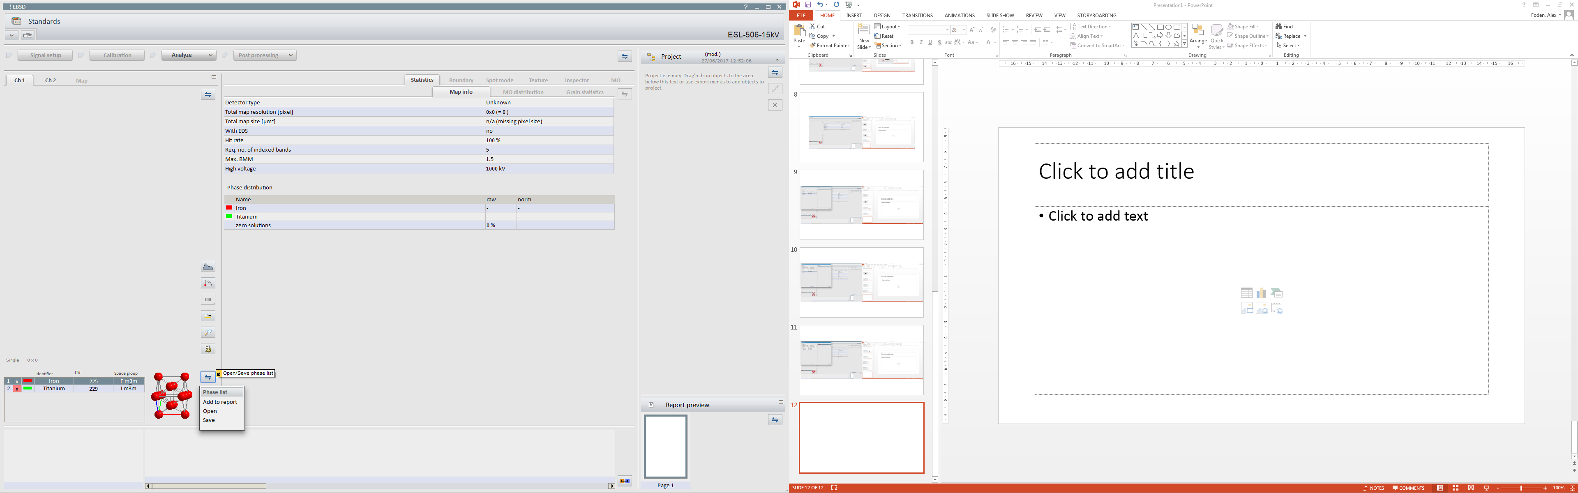

This will open a new window. 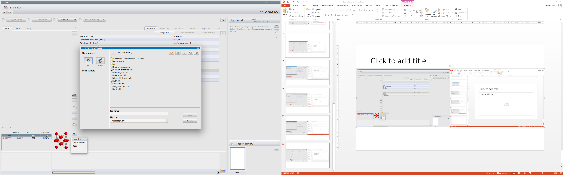

### Using *DynamicS*

Open *DynamicS*

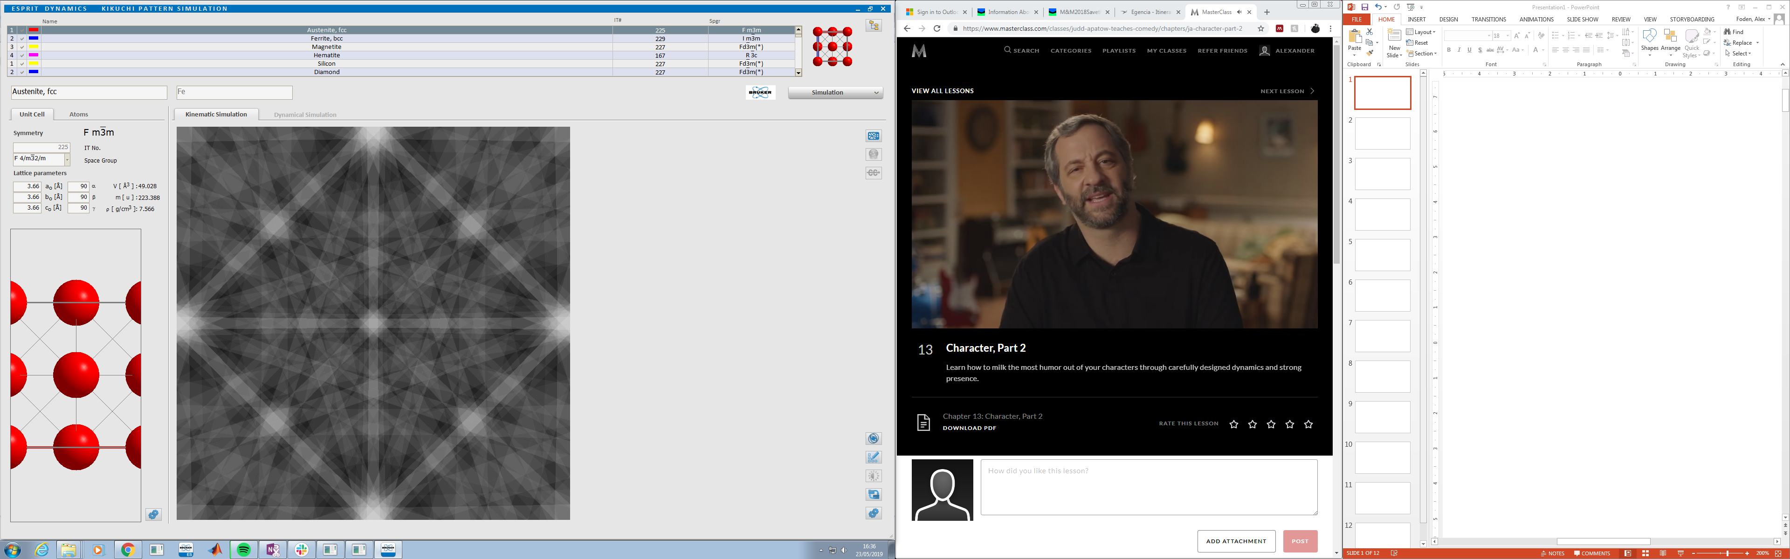

To load the Phase list, click the three files button in the top right hand corner and select *Load*

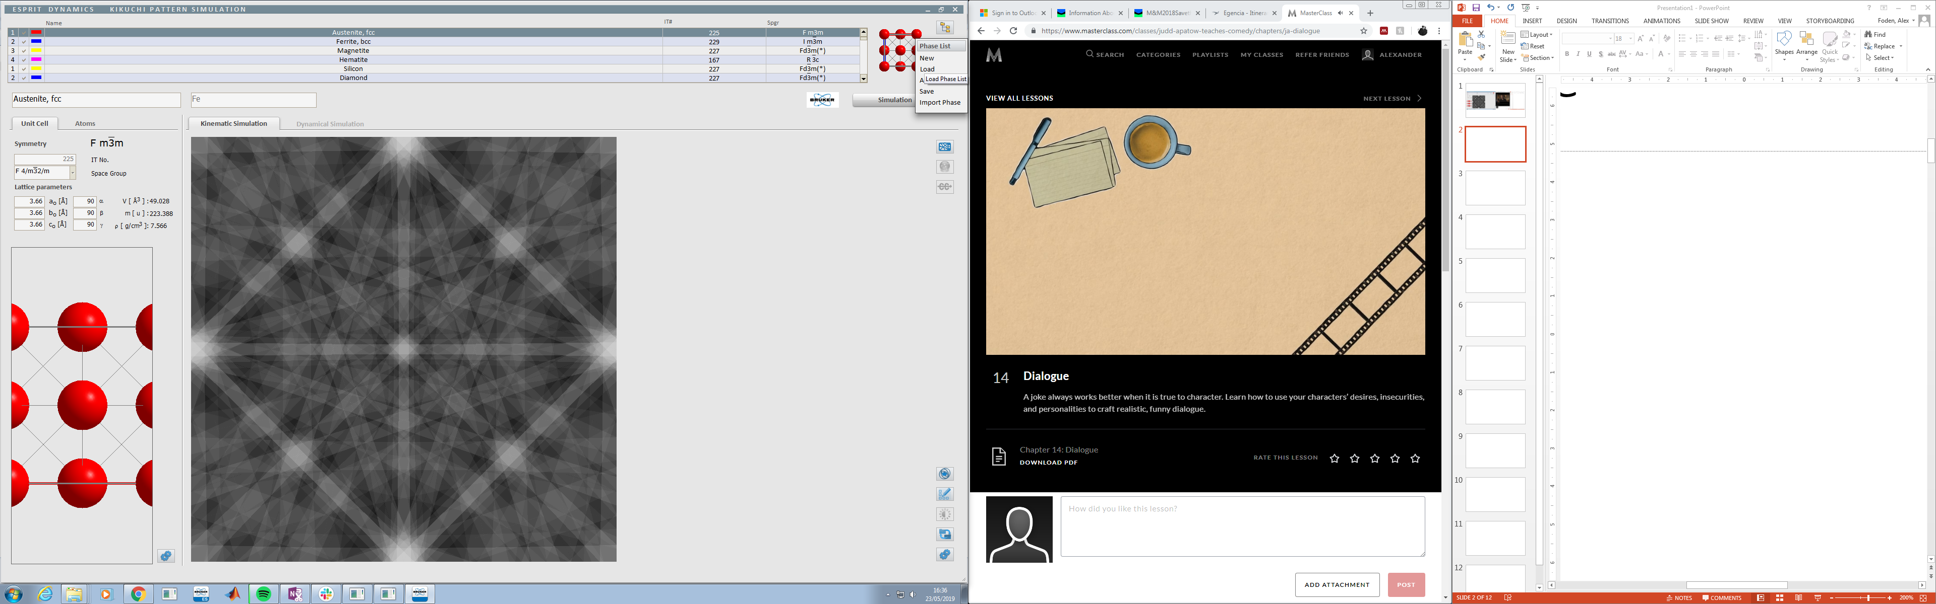

This will open up a new window for you to select your phase list from

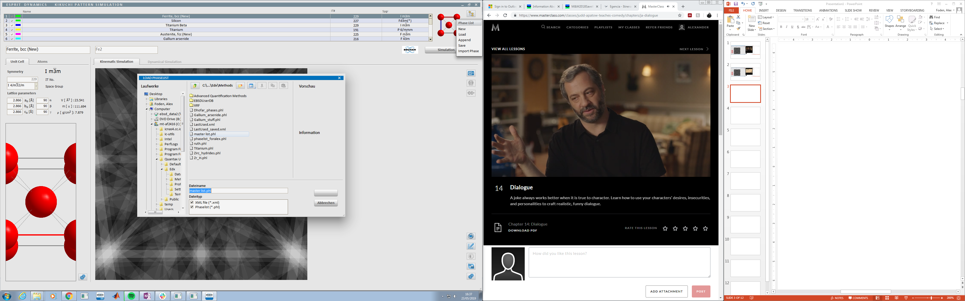

Double click your phase list to select it, this will open it in *DynamicS.* Then double click on the phase you wish to simulate

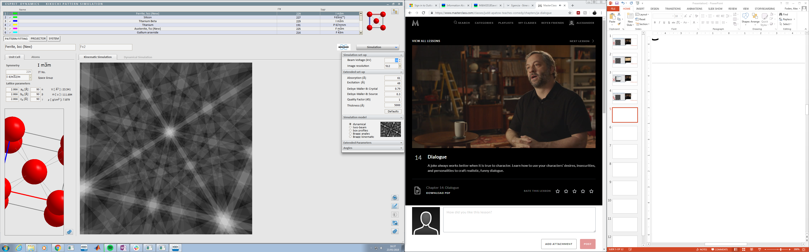

On the top right hand side, click the small arrow inside the simulation button, this will give you a drop down menu where you can select the simulation settings, such as beam voltage etc.



Set the image resolution to either 1024 or 2048, otherwise the patterns used in the library will be too low in quality to do the matching

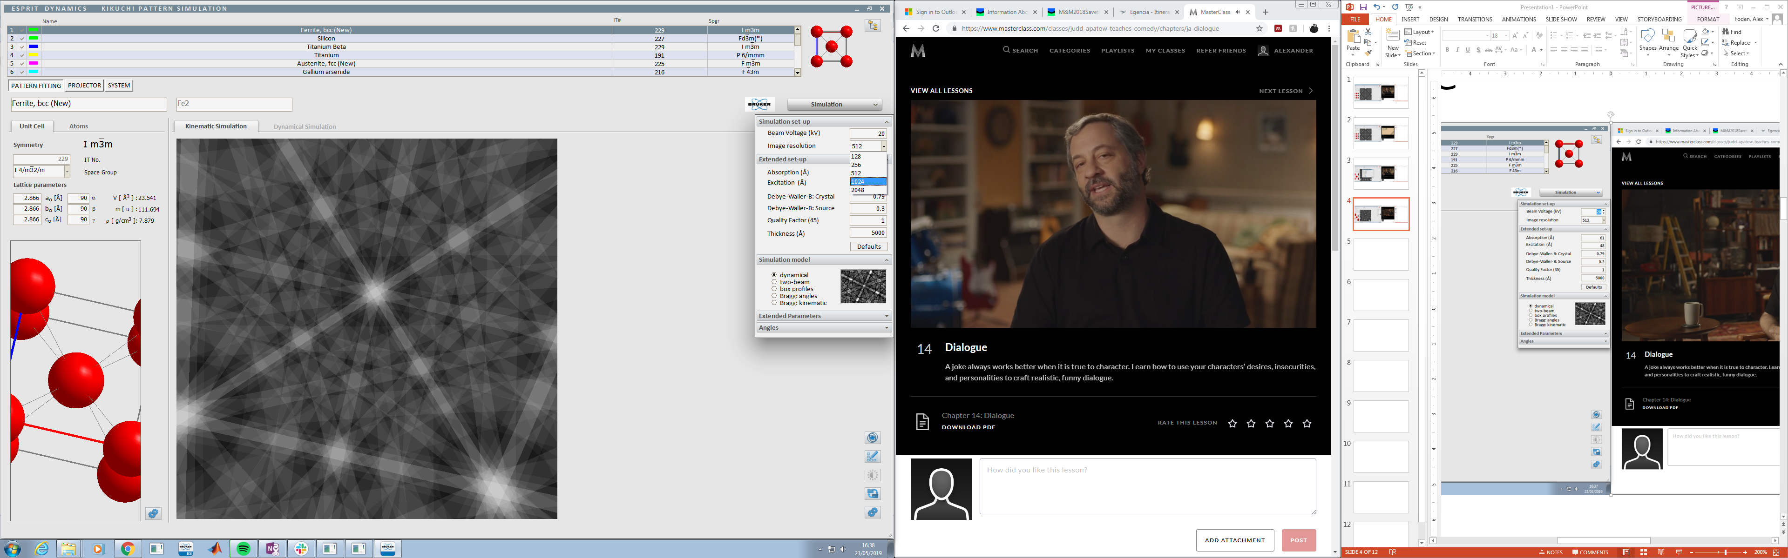

Click the *Simulation* button. This will run the simulation and change the button to a progress bar.

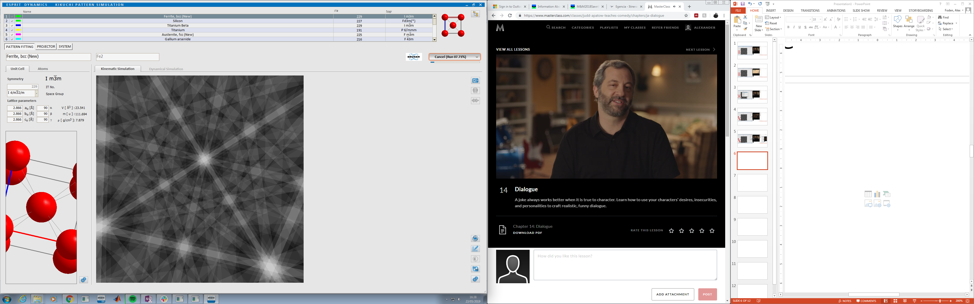

One the simulation has run, on the keyboard, press *ctrl + u*. This will give you three new buttons under the phase list. Click the *Projector* button.  
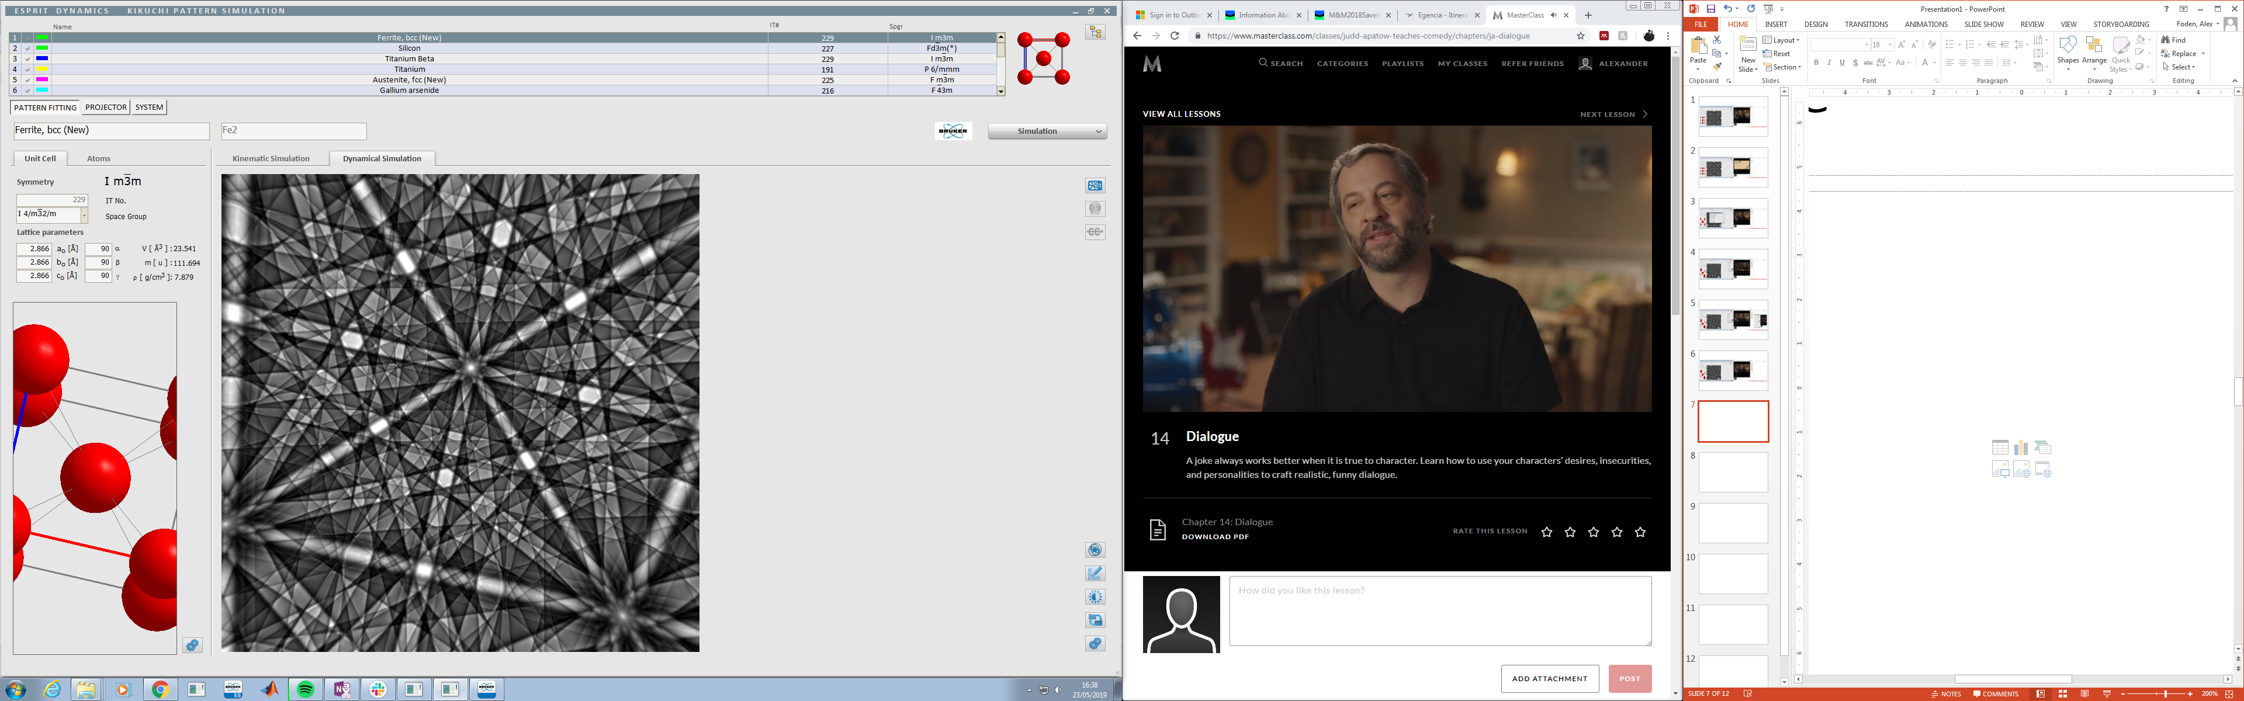

In the new screen select *Save BIN*

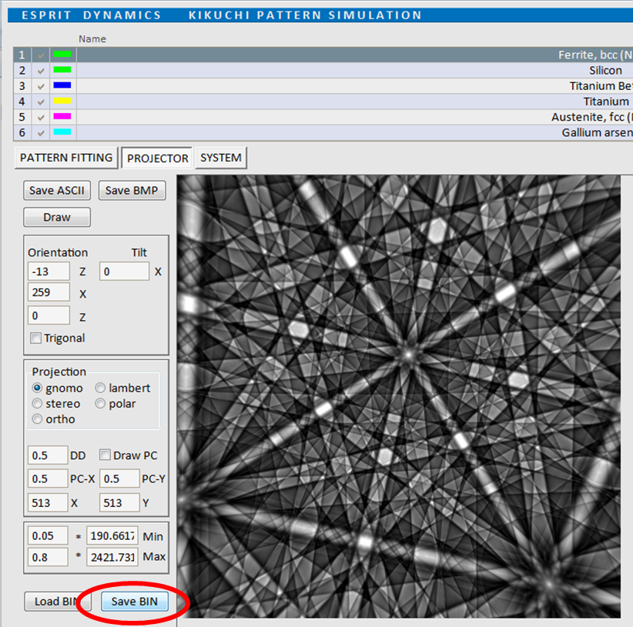

This will open a new window for you to save the file

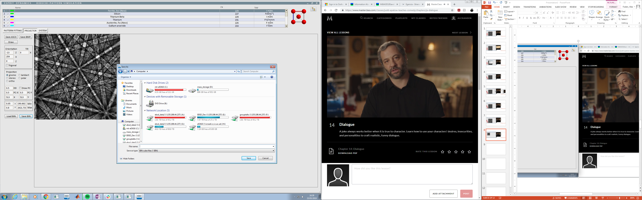

## Phase Files

Phase files are a handmade file containing information relevant to AstroEBSD (<https://doi.org/10.1107/S1600576718010373>) and the refined template approach described here.

The file itself looks like this, with the information relevant to the template matching highlighted in green.

The easiest way to make one is to save it as a .txt file, then change the file extension to .pha.

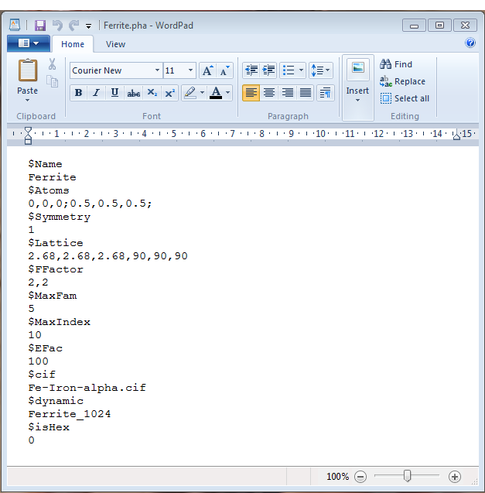

A lot of the information in the red section is copied directly from the CIF and is only needed for AstroEBSD.

#### The Relevant Information

**$cif**: This is the name of the CIF file. It can either be an mtex default, or stored in \AstroEBSD_v2\phases\cifs

**$dynamic**

This is the name and location of the BIN file relevant to your crystal structure, this works the same way as the $cif file section. These are stored \AstroEBSD_v2\phases\masterpatterns.

**$isHex**

This determines if the material is a hexagonal unit cell or not, this is important in the rebuild of the EBSD data.

For hexagonal materials

*$isHex*

*1*

For non-hexagonal materials

*$isHex*

*0*